Mrs. Cineus’ Wonder’s Weekly To-Do List
- Unit 4 Week 4 – May 11th –May 15th
- Once worksheet pages are complete screenshot with electronic device and send via remind.
- Assignments can be turned in as students complete them or all at one time, whichever is convenient for you
- Everyday students should complete 20 minutes and 20 minutes of I-Ready Reading.
Monday | Tuesday | Wednesday | Thursday | Friday
- Complete Unit 4 Week 4 Vocabulary in journal or on paper. Vocabulary words can be found on connected, in the words to know tab. Students should define word and use word in a sentence.  - Vocabulary words are;  - Controlled  - Direction  - Flight  - Impossible  - Launched  - Motion  - Passenger  - Popular | - Complete page 114-117 from Ready Book   | - Complete pages 191 and 207 from Your Turn Book.   | - Read the assigned story “Manatees in student mailbox and take quiz use the link below. Don’t forget to take an AR test  https://www.getepic.com/students  Class code: pra0590  - Complete “ The Stubborn Mule that Wanted to take his Own Path” from workshop folder,  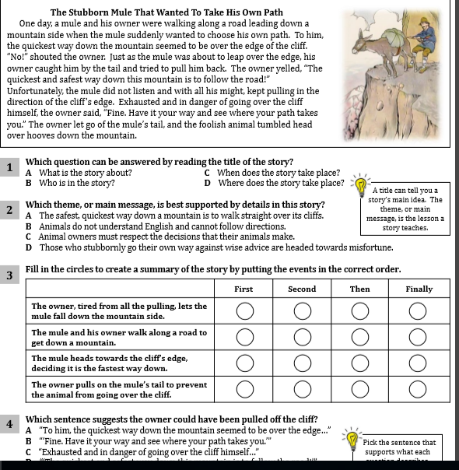 | Social Studies Assignment:  - Watch the Video about the state of Texas and Louisiana and write 3 interesting fact in your journal.  https://www.youtube.com/watch?v=2Jpgd8yKpUI  https://www.youtube.com/watch?v=IZTSj0u5hZo  Have a great weekend!

